Scp

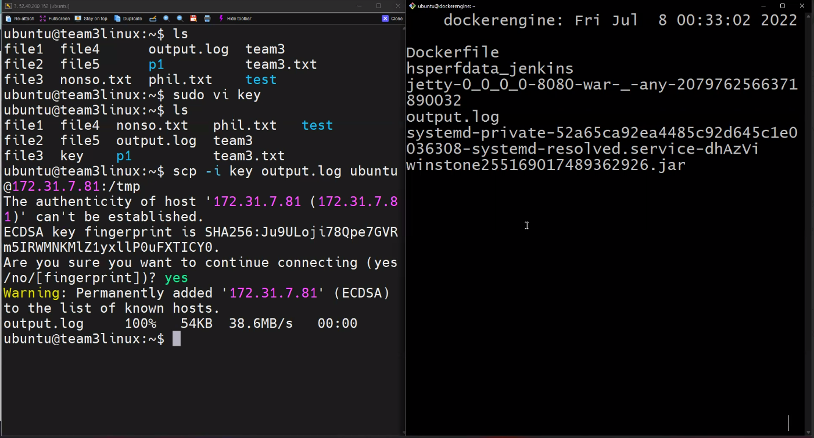

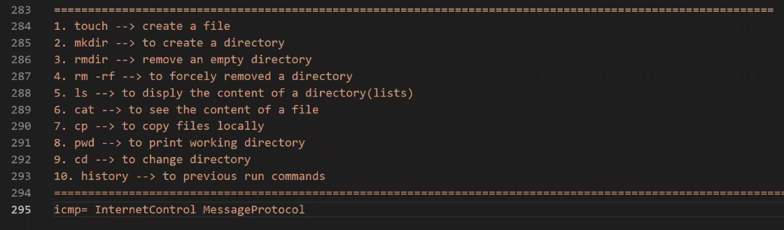

Adding user



